Топология по лабе:
Работа со switch2 – настройка его ip
Switch2(config)#interface vlan 72
Switch2(config-if)#ip address 192.168.13.10 255.255.255.0
Switch2(config-if)#no shutdown
Switch2(config-if)#do show ip interface brief
Interface IP-Address OK? Method Status Protocol
FastEthernet0/1 unassigned YES manual up up
FastEthernet0/2 unassigned YES manual up up
FastEthernet0/3 unassigned YES manual up up
FastEthernet0/4 unassigned YES manual down down
FastEthernet0/5 unassigned YES manual down down
FastEthernet0/6 unassigned YES manual down down
FastEthernet0/7 unassigned YES manual down down
FastEthernet0/8 unassigned YES manual down down
FastEthernet0/9 unassigned YES manual down down
FastEthernet0/10 unassigned YES manual down down
FastEthernet0/11 unassigned YES manual down down
FastEthernet0/12 unassigned YES manual down down
FastEthernet0/13 unassigned YES manual down down
FastEthernet0/14 unassigned YES manual down down
FastEthernet0/15 unassigned YES manual down down
FastEthernet0/16 unassigned YES manual down down
FastEthernet0/17 unassigned YES manual down down
FastEthernet0/18 unassigned YES manual down down
FastEthernet0/19 unassigned YES manual down down
FastEthernet0/20 unassigned YES manual down down
FastEthernet0/21 unassigned YES manual down down
FastEthernet0/22 unassigned YES manual down down
FastEthernet0/23 unassigned YES manual down down
FastEthernet0/24 unassigned YES manual down down
GigabitEthernet0/1 unassigned YES manual down down
GigabitEthernet0/2 unassigned YES manual down down
Vlan1 unassigned YES manual administratively down down
Vlan72 192.168.13.10 YES manual down down

VLAN интерфейс показывает статус UP только когда есть активные порты в этом VLAN

Switch2(config)#interface fastethernet 0/1
Switch2(config-if)#switchport mode access
Switch2(config-if)#switchport access vlan 72
% Access VLAN does not exist. Creating vlan 72
Switch2(config-if)#
%LINK-5-CHANGED: Interface Vlan72, changed state to up
%LINEPROTO-5-UPDOWN: Line protocol on Interface Vlan72, changed state to up
Switch2(config-if)#no shutdown

Switch2(config)#interface fastethernet 0/3
Switch2(config-if)#switchport mode access
Switch2(config-if)#switchport access vlan 72
Switch2(config-if)#no shutdown

Switch2(config-if)#do show ip interface brief
Interface IP-Address OK? Method Status Protocol
FastEthernet0/1 unassigned YES manual up up
FastEthernet0/2 unassigned YES manual up up
FastEthernet0/3 unassigned YES manual up up
FastEthernet0/4 unassigned YES manual down down
FastEthernet0/5 unassigned YES manual down down
FastEthernet0/6 unassigned YES manual down down
FastEthernet0/7 unassigned YES manual down down
FastEthernet0/8 unassigned YES manual down down
FastEthernet0/9 unassigned YES manual down down
FastEthernet0/10 unassigned YES manual down down
FastEthernet0/11 unassigned YES manual down down
FastEthernet0/12 unassigned YES manual down down
FastEthernet0/13 unassigned YES manual down down
FastEthernet0/14 unassigned YES manual down down
FastEthernet0/15 unassigned YES manual down down
FastEthernet0/16 unassigned YES manual down down
FastEthernet0/17 unassigned YES manual down down
FastEthernet0/18 unassigned YES manual down down
FastEthernet0/19 unassigned YES manual down down
FastEthernet0/20 unassigned YES manual down down
FastEthernet0/21 unassigned YES manual down down
FastEthernet0/22 unassigned YES manual down down
FastEthernet0/23 unassigned YES manual down down
FastEthernet0/24 unassigned YES manual down down
GigabitEthernet0/1 unassigned YES manual down down
GigabitEthernet0/2 unassigned YES manual down down
Vlan1 unassigned YES manual administratively down down
Vlan72 192.168.13.10 YES manual up up

Настраиваю ip для pc0 pc1
switch 192.168.13.10
pc0 - 192.168.13.20
pc1 - 192.168.13.21

Настройка switch1
Switch>enable
Switch#conf t
Enter configuration commands, one per line. End with CNTL/Z.
Switch(config)#hostname Switch1
Switch1(config)#interface vlan 27
Switch1(config-if)#ip address 192.168.14.11 255.255.255.0
Switch1(config-if)#do show ip interface brief
Interface IP-Address OK? Method Status Protocol
FastEthernet0/1 unassigned YES manual up up
FastEthernet0/2 unassigned YES manual up up
FastEthernet0/3 unassigned YES manual down down
FastEthernet0/4 unassigned YES manual down down
FastEthernet0/5 unassigned YES manual down down
FastEthernet0/6 unassigned YES manual down down
FastEthernet0/7 unassigned YES manual down down
FastEthernet0/8 unassigned YES manual down down
FastEthernet0/9 unassigned YES manual down down
FastEthernet0/10 unassigned YES manual down down
FastEthernet0/11 unassigned YES manual down down
FastEthernet0/12 unassigned YES manual down down
FastEthernet0/13 unassigned YES manual down down
FastEthernet0/14 unassigned YES manual down down
FastEthernet0/15 unassigned YES manual down down
FastEthernet0/16 unassigned YES manual down down
FastEthernet0/17 unassigned YES manual down down
FastEthernet0/18 unassigned YES manual down down
FastEthernet0/19 unassigned YES manual down down
FastEthernet0/20 unassigned YES manual down down
FastEthernet0/21 unassigned YES manual down down
FastEthernet0/22 unassigned YES manual down down
FastEthernet0/23 unassigned YES manual down down
FastEthernet0/24 unassigned YES manual down down
GigabitEthernet0/1 unassigned YES manual down down
GigabitEthernet0/2 unassigned YES manual down down
Vlan1 unassigned YES manual administratively down down
Vlan27 192.168.14.11 YES manual down down
Switch1(config-if)#exit
Switch1(config)#interface fastethernet 0/2
Switch1(config-if)#switchport mode access
Switch1(config-if)#switchport access vlan 27
% Access VLAN does not exist. Creating vlan 27
Switch1(config-if)#
%LINK-5-CHANGED: Interface Vlan27, changed state to up

%LINEPROTO-5-UPDOWN: Line protocol on Interface Vlan27, changed state to up

Switch1(config-if)#no shutdown
Switch1(config-if)#do show ip interface brief
Interface IP-Address OK? Method Status Protocol
FastEthernet0/1 unassigned YES manual up up
FastEthernet0/2 unassigned YES manual up up
FastEthernet0/3 unassigned YES manual down down
FastEthernet0/4 unassigned YES manual down down
FastEthernet0/5 unassigned YES manual down down
FastEthernet0/6 unassigned YES manual down down
FastEthernet0/7 unassigned YES manual down down
FastEthernet0/8 unassigned YES manual down down
FastEthernet0/9 unassigned YES manual down down
FastEthernet0/10 unassigned YES manual down down
FastEthernet0/11 unassigned YES manual down down
FastEthernet0/12 unassigned YES manual down down
FastEthernet0/13 unassigned YES manual down down
FastEthernet0/14 unassigned YES manual down down
FastEthernet0/15 unassigned YES manual down down
FastEthernet0/16 unassigned YES manual down down
FastEthernet0/17 unassigned YES manual down down
FastEthernet0/18 unassigned YES manual down down
FastEthernet0/19 unassigned YES manual down down
FastEthernet0/20 unassigned YES manual down down
FastEthernet0/21 unassigned YES manual down down
FastEthernet0/22 unassigned YES manual down down
FastEthernet0/23 unassigned YES manual down down
FastEthernet0/24 unassigned YES manual down down
GigabitEthernet0/1 unassigned YES manual down down
GigabitEthernet0/2 unassigned YES manual down down
Vlan1 unassigned YES manual administratively down down
Vlan27 192.168.13.11 YES manual up up

SWITCH 0
Switch0>enable
Switch0#conf t
Enter configuration commands, one per line. End with CNTL/Z.
Switch0(config)#interface vlan 72
Switch0(config-if)#ip address 192.168.13.12 255.255.255.0
Switch0(config-if)#exit
Switch0(config)#interface fastethernet 0/2
Switch0(config-if)#switchport mode trunk

Switch0(config-if)#
%LINEPROTO-5-UPDOWN: Line protocol on Interface FastEthernet0/2, changed state to down

%LINEPROTO-5-UPDOWN: Line protocol on Interface FastEthernet0/2, changed state to up

Switch0(config-if)#switchport trunk allowed vlan 72,27
Switch0(config-if)#no shutdown

Switch0(config)#ip default-gateway 192.168.13.1

Switch0(config)#interface vlan 72
Switch0(config-if)#no shutdown
Switch0(config-if)#exit

Создать VLAN на Switch0
Switch0(config)#vlan 72
Switch0(config-vlan)#
%LINK-5-CHANGED: Interface Vlan72, changed state to up

%LINEPROTO-5-UPDOWN: Line protocol on Interface Vlan72, changed state to up

Switch0(config-vlan)#exit
Switch0(config)#vlan 27
Switch0(config-vlan)#exit
Switch0(config)#do show interface trunk
Port Mode Encapsulation Status Native vlan
Fa0/1 on 802.1q trunking 1
Fa0/2 on 802.1q trunking 1
Fa0/3 on 802.1q trunking 1

Port Vlans allowed on trunk
Fa0/1 27,72
Fa0/2 27,72
Fa0/3 27,72

Port Vlans allowed and active in management domain
Fa0/1 27,72
Fa0/2 27,72
Fa0/3 27,72

Port Vlans in spanning tree forwarding state and not pruned
Fa0/1 none
Fa0/2 none
Fa0/3 none

SWITCH 2
Switch2>enable
Switch2#conf t
Enter configuration commands, one per line. End with CNTL/Z.
Switch2(config)#interface fastethernet 0/2
Switch2(config-if)#switchport mode trunk
Switch2(config-if)#switchport trunk allowed vlan 72,27
Switch2(config-if)#no shutdown
Switch2(config-if)#do show ip interface brief
Interface IP-Address OK? Method Status Protocol
FastEthernet0/1 unassigned YES manual up up
FastEthernet0/2 unassigned YES manual up up
FastEthernet0/3 unassigned YES manual up up
FastEthernet0/4 unassigned YES manual down down
FastEthernet0/5 unassigned YES manual down down
FastEthernet0/6 unassigned YES manual down down
FastEthernet0/7 unassigned YES manual down down
FastEthernet0/8 unassigned YES manual down down
FastEthernet0/9 unassigned YES manual down down
FastEthernet0/10 unassigned YES manual down down
FastEthernet0/11 unassigned YES manual down down
FastEthernet0/12 unassigned YES manual down down
FastEthernet0/13 unassigned YES manual down down
FastEthernet0/14 unassigned YES manual down down
FastEthernet0/15 unassigned YES manual down down
FastEthernet0/16 unassigned YES manual down down
FastEthernet0/17 unassigned YES manual down down
FastEthernet0/18 unassigned YES manual down down
FastEthernet0/19 unassigned YES manual down down
FastEthernet0/20 unassigned YES manual down down
FastEthernet0/21 unassigned YES manual down down
FastEthernet0/22 unassigned YES manual down down
FastEthernet0/23 unassigned YES manual down down
FastEthernet0/24 unassigned YES manual down down
GigabitEthernet0/1 unassigned YES manual down down
GigabitEthernet0/2 unassigned YES manual down down
Vlan1 unassigned YES manual administratively down down
Vlan72 192.168.13.10 YES manual up up

Switch2(config)#ip default-gateway 192.168.13.1

SWITCH 1
Switch1(config)#interface fastethernet 0/1
Switch1(config-if)#switchport mode trunk

Switch1(config-if)#
%LINEPROTO-5-UPDOWN: Line protocol on Interface FastEthernet0/1, changed state to down

%LINEPROTO-5-UPDOWN: Line protocol on Interface FastEthernet0/1, changed state to up

Switch1(config-if)#switchport trunk allowed vlan 72,27
Switch1(config-if)#no shutdown
Switch1(config-if)#do show ip interface brief
Interface IP-Address OK? Method Status Protocol
FastEthernet0/1 unassigned YES manual up up
FastEthernet0/2 unassigned YES manual up up
FastEthernet0/3 unassigned YES manual down down
FastEthernet0/4 unassigned YES manual down down
FastEthernet0/5 unassigned YES manual down down
FastEthernet0/6 unassigned YES manual down down
FastEthernet0/7 unassigned YES manual down down
FastEthernet0/8 unassigned YES manual down down
FastEthernet0/9 unassigned YES manual down down
FastEthernet0/10 unassigned YES manual down down
FastEthernet0/11 unassigned YES manual down down
FastEthernet0/12 unassigned YES manual down down
FastEthernet0/13 unassigned YES manual down down
FastEthernet0/14 unassigned YES manual down down
FastEthernet0/15 unassigned YES manual down down
FastEthernet0/16 unassigned YES manual down down
FastEthernet0/17 unassigned YES manual down down
FastEthernet0/18 unassigned YES manual down down
FastEthernet0/19 unassigned YES manual down down
FastEthernet0/20 unassigned YES manual down down
FastEthernet0/21 unassigned YES manual down down
FastEthernet0/22 unassigned YES manual down down
FastEthernet0/23 unassigned YES manual down down
FastEthernet0/24 unassigned YES manual down down
GigabitEthernet0/1 unassigned YES manual down down
GigabitEthernet0/2 unassigned YES manual down down
Vlan1 unassigned YES manual administratively down down
Vlan27 192.168.14.11 YES manual up up

Switch1(config)#ip default-gateway 192.168.14.1

Настроить trunk к Router0 на Switch0
Switch0(config)#ip default-gateway 192.168.13.1
Switch0(config)#interface fastethernet 0/3
Switch0(config-if)#switchport mode trunk
Switch0(config-if)#switchport trunk allowed vlan 72,27
Switch0(config-if)#no shutdown

Настройка Router0
Router> enable
Router# configure terminal

! Суб-интерфейс для VLAN 72
Router(config)# interface gigabitethernet 0/0.72
Router(config-subif)# encapsulation dot1Q 72
Router(config-subif)# ip address 192.168.13.1 255.255.255.0
Router(config-subif)# no shutdown
Router(config-subif)# exit

! Суб-интерфейс для VLAN 27
Router(config)# interface gigabitethernet 0/0.27
Router(config-subif)# encapsulation dot1Q 27
Router(config-subif)# ip address 192.168.14.1 255.255.255.0
Router(config-subif)# no shutdown
Router(config-subif)# exit

! Основной интерфейс
Router(config)# interface gigabitethernet 0/0
Router(config-if)# no shutdown
Router(config-if)# exit

Router#show ip interface brief
Interface IP-Address OK? Method Status Protocol
GigabitEthernet0/0 unassigned YES unset up up
GigabitEthernet0/0.27 192.168.14.1 YES manual up up
GigabitEthernet0/0.72 192.168.13.1 YES manual up up
GigabitEthernet0/1 unassigned YES unset administratively down down
GigabitEthernet0/2 unassigned YES unset administratively down down
Vlan1 unassigned YES unset administratively down down

Router#show running-config
interface GigabitEthernet0/0
no ip address
duplex auto
speed auto
!
interface GigabitEthernet0/0.27
encapsulation dot1Q 27
ip address 192.168.14.1 255.255.255.0
!
interface GigabitEthernet0/0.72
encapsulation dot1Q 72
ip address 192.168.13.1 255.255.255.0
!
interface GigabitEthernet0/1
no ip address
duplex auto
speed auto
shutdown
!
interface GigabitEthernet0/2
no ip address
duplex auto
speed auto
shutdown
!
interface Vlan1
no ip address
shutdown
!
ip classless
!
ip flow-export version 9

Switch4
Switch>enable
Switch#conf t
Enter configuration commands, one per line. End with CNTL/Z.
Switch(config)#hostname Switch4
Switch4(config)#vlan 72
Switch4(config-vlan)#name VLAN72_Network
Switch4(config-vlan)#exit

Switch4(config)#interface vlan 72
Switch4(config-if)#
%LINK-5-CHANGED: Interface Vlan72, changed state to up
Switch4(config-if)#ip address 192.168.15.14 255.255.255.0
Switch4(config-if)#no shutdown
Switch4(config-if)#exit
Switch4(config)# ip default-gateway 192.168.15.1

Switch4(config)#interface range fastethernet 0/2-3
Switch4(config-if-range)#switchport mode access
Switch4(config-if-range)#switchport access vlan 72
Switch4(config-if-range)#
%LINEPROTO-5-UPDOWN: Line protocol on Interface Vlan72, changed state to up
Switch4(config-if-range)#no shutdown
Switch4(config-if-range)#exit
Switch4(config)#interface fastethernet 0/1
Switch4(config-if)#switchport mode trunk

Switch4(config-if)#
%LINEPROTO-5-UPDOWN: Line protocol on Interface FastEthernet0/1, changed state to down

%LINEPROTO-5-UPDOWN: Line protocol on Interface FastEthernet0/1, changed state to up

Switch4(config-if)#switchport trunk allowed vlan 72,27
Switch4(config-if)#no shutdown
Switch4(config-if)#exit

Switch5
Switch>enable
Switch#conf t
Enter configuration commands, one per line. End with CNTL/Z.
Switch(config)#hostname Switch5
Switch5(config)#vlan 27
Switch5(config-vlan)#name VLAN27_Network
Switch5(config-vlan)#exit

Switch5(config)#interface fastethernet 0/1
Switch5(config-if)#switchport mode access
Switch5(config-if)#switchport access vlan 27
Switch5(config-if)#no shutdown
Switch5(config-if)#exit

Switch5(config)#interface fastethernet 0/2
Switch5(config-if)#switchport mode trunk
Switch5(config-if)#
%LINEPROTO-5-UPDOWN: Line protocol on Interface FastEthernet0/2, changed state to down
%LINEPROTO-5-UPDOWN: Line protocol on Interface FastEthernet0/2, changed state to up
Switch5(config-if)#switchport trunk allowed vlan 72,27
Switch5(config-if)#no shutdown
Switch5(config-if)#exit

Switch5(config)#interface vlan 27
Switch5(config-if)#
%LINK-5-CHANGED: Interface Vlan27, changed state to up
%LINEPROTO-5-UPDOWN: Line protocol on Interface Vlan27, changed state to up
Switch5(config-if)#ip address 192.168.16.15 255.255.255.0
Switch5(config-if)#no shutdown
Switch5(config-if)#exit
Switch5(config)# ip default-gateway 192.168.16.1

Switch6
Switch>enable
Switch#conf t
Enter configuration commands, one per line. End with CNTL/Z.
Switch(config)#hostname Switch6
Switch6(config)#vlan 27
Switch6(config-vlan)#name VLAN27_Network
Switch6(config-vlan)#exit

Switch6(config)#interface fastethernet 0/1
Switch6(config-if)#switchport mode access
Switch6(config-if)#switchport access vlan 27
Switch6(config-if)#no shutdown
Switch6(config-if)#exit
Switch6(config)#interface fastethernet 0/3
Switch6(config-if)#switchport mode trunk
Switch6(config-if)#
%LINEPROTO-5-UPDOWN: Line protocol on Interface FastEthernet0/3, changed state to down
%LINEPROTO-5-UPDOWN: Line protocol on Interface FastEthernet0/3, changed state to up
Switch6(config-if)#switchport trunk allowed vlan 72,27
Switch6(config-if)#no shutdown
Switch6(config-if)#exit

Switch6(config)#interface vlan 27
Switch6(config-if)#
%LINK-5-CHANGED: Interface Vlan27, changed state to up
%LINEPROTO-5-UPDOWN: Line protocol on Interface Vlan27, changed state to up
Switch6(config-if)#ip address 192.168.16.16 255.255.255.0
Switch6(config-if)#no shutdown
Switch6(config-if)#exit
Switch6(config)# ip default-gateway 192.168.16.1

Switch3
Switch>enable
Switch#conf t
Enter configuration commands, one per line. End with CNTL/Z.
Switch(config)#hostname Switch3
Switch3(config)#vlan 72
Switch3(config-vlan)#name VLAN72_Network
Switch3(config-vlan)#exit
Switch3(config)#vlan 27
Switch3(config-vlan)#name VLAN27_Network
Switch3(config-vlan)#exit
Switch3(config)#interface gigabitethernet 0/1
Switch3(config-if)#switchport mode trunk
Switch3(config-if)#switchport trunk allowed vlan 72,27
Switch3(config-if)#no shutdown
Switch3(config-if)#exit
Switch3(config)#interface range fastethernet 0/1-3
Switch3(config-if-range)#switchport mode trunk
Switch3(config-if-range)#switchport trunk allowed vlan 72,27
Switch3(config-if-range)#no shutdown
Switch3(config-if-range)#exit
Switch3(config)#interface vlan 72
Switch3(config-if)#
%LINK-5-CHANGED: Interface Vlan72, changed state to up

%LINEPROTO-5-UPDOWN: Line protocol on Interface Vlan72, changed state to up

Switch3(config-if)#ip address 192.168.13.13 255.255.255.0
Switch3(config-if)#no shutdown
Switch3(config-if)#exit
Switch3(config)#ip default-gateway 192.168.15.1

Router
Router(config)#interface gigabitethernet 0/1.72
Router(config-subif)#encapsulation dot1Q 72
Router(config-subif)#ip address 192.168.15.1 255.255.255.0
Router(config-subif)#no shutdown
Router(config-subif)#exit
Router(config)#interface gigabitethernet 0/1.27
Router(config-subif)#encapsulation dot1Q 72

%Configuration of multiple subinterfaces of the same main
interface with the same VID (72) is not permitted.
This VID is already configured on GigabitEthernet0/1.72.

Router(config-subif)#encapsulation dot1Q 27
Router(config-subif)#ip address 192.168.16.1 255.255.255.0
Router(config-subif)#no shutdown
Router(config-subif)#exit
Router(config)#do show ip interface brief
Interface IP-Address OK? Method Status Protocol
GigabitEthernet0/0 unassigned YES unset up up
GigabitEthernet0/0.27 192.168.14.1 YES manual up up
GigabitEthernet0/0.72 192.168.13.1 YES manual up up
GigabitEthernet0/1 unassigned YES unset up up
GigabitEthernet0/1.27 192.168.16.1 YES manual up up
GigabitEthernet0/1.72 192.168.15.1 YES manual up up
GigabitEthernet0/2 unassigned YES unset administratively down down
Vlan1 unassigned YES unset administratively down down

https://chat.deepseek.com/a/chat/s/30e026de-34b3-48fa-8d5e-8bcd2f2137eb

Аутентификация
Switch2(config)#username meadmin privilege 15 password 1234
Switch2(config)#line vty 0 15
Switch2(config-line)#login local
Switch2(config-line)#transport input telnet
Switch2(config-line)#exit
copy running-config startup-config

Пример с PC0
C:\>telnet 192.168.13.10
Trying 192.168.13.10 ...Open
User Access Verification
Username: meadmin

Разница между Access и Trunk портами.
Access Port (Пользовательский порт)
Назначение:
Подключение конечных устройств - компьютеров, принтеров, IP-камер, серверов
Характеристики:
- Передает трафик только одного VLAN
- Не добавляет теги VLAN к кадрам
- "Верит" устройству на другом конце

Настройка:
bash
interface fastethernet 0/1
switchport mode access
switchport access vlan 72

Trunk Port (Магистральный порт)
Назначение:
Соединение между сетевыми устройствами - коммутаторами, маршрутизаторами
Характеристики:
- Передает трафик нескольких VLAN одновременно
- Добавляет теги VLAN (802.1Q) к кадрам
- "Не верит" устройству на другом конце

Настройка:
bash
interface gigabitethernet 0/1
switchport mode trunk
switchport trunk native vlan 99
switchport trunk allowed vlan 10,20,30,72

- Пользовательский режим (Router>)
- Привилегированный режим (Router#)
- Режим глобальной конфигурации (Router(config)#)
Router> enable
Router# configure terminal (или Router# conf t)
Router(config)#

Что можно делать в режиме глобальной конфигурации:
Создание VLAN (виртуальных локальных сетей):
Router(config)# vlan 10
Router(config-vlan)# name Sales
Настройка протоколов маршрутизации (OSPF, EIGRP):
Router(config)# router ospf 1
Router(config-router)# network 192.168.1.0 0.0.0.255 area 0
Настройка hostname устройства:
Router(config)# hostname MyOffice-Switch
MyOffice-Switch(config)#

Hostname устройства — это его сетевое имя, которое используется для идентификации в сети.

Настройка имени хоста
Switch>enable
Switch#conf t
Enter configuration commands, one per line. End with CNTL/Z.
Switch(config)#hostname Switch13
Switch13(config)#

Настройка парольной защиты
Switch13(config)#enable password iu3
Switch13(config)#exit
Switch13#
Switch13#show run
Building configuration...

Current configuration : 1104 bytes
!
version 15.0
no service timestamps log datetime msec
no service timestamps debug datetime msec
no service password-encryption
!
hostname Switch13
!
enable password iu3
!
!
!
!
!
!
spanning-tree mode pvst
spanning-tree extend system-id
!
interface FastEthernet0/1
--More--

Errors (надо нажать Ctrl+Shift+6)
Switch13# ^
Translating "^"...domain server (255.255.255.255) % Name lookup aborted
Switch13#

Настройка зашифрованного пароля доступа к привилегированному режиму
Switch13>enable
Password:
Switch13#conf t
Enter configuration commands, one per line. End with CNTL/Z.
Switch13(config)#enable secret cisco
Switch13(config)#do show run
Building configuration...

Current configuration : 1151 bytes
!
version 15.0
no service timestamps log datetime msec
no service timestamps debug datetime msec
no service password-encryption
!
hostname Switch13
!
enable secret 5 $1$mERr$hx5rVt7rPNoS4wqbXKX7m0
enable password iu3
!
!
!
!
!
!
spanning-tree mode pvst
spanning-tree extend system-id
!
--More--

После добавления пароля secret простой пароль уже не работает.

VTY (Virtual Teletype) — это виртуальные линии для удаленного доступа к устройству по протоколам Telnet и SSH.
Простыми словами: это "виртуальные дверцы" через которые можно подключиться к маршрутизатору или коммутатору удаленно по сети, а не через физическую консоль.

Что означают цифры 0 15?
- 0 15 означает, что мы настраиваем 16 виртуальных линий (от 0 до 15 включительно)
- Это позволяет одновременно подключиться к устройству 16 разным пользователям по Telnet/SSH

Настройка пароля линий VTY
Switch13>enable
Password:
Switch13#conf t
Enter configuration commands, one per line. End with CNTL/Z.
Switch13(config)#line vty 0 15
Switch13(config-line)#password vty
Switch13(config-line)#login
Switch13(config-line)#do show run | section line
line con 0
line vty 0 4
password vty
login
line vty 5 15
password vty
login

Служба шифрования пароля
Switch13(config-line)#do show run | section line
line con 0
line vty 0 4
password vty
login
line vty 5 15
password vty
login

Switch13#show run
Building configuration...

Current configuration : 1179 bytes
!
version 15.0
no service timestamps log datetime msec
no service timestamps debug datetime msec
no service password-encryption
!
hostname Switch13
!
enable secret 5 $1$mERr$hx5rVt7rPNoS4wqbXKX7m0
enable password iu3
!
!
!
!
!
!
spanning-tree mode pvst
spanning-tree extend system-id

Switch13#conf t
Enter configuration commands, one per line. End with CNTL/Z.
Switch13(config)#service password-encryption
Switch13(config)#
Switch13#
%SYS-5-CONFIG_I: Configured from console by console

Switch13#show run
Building configuration...

Current configuration : 1197 bytes
!
version 15.0
no service timestamps log datetime msec
no service timestamps debug datetime msec
service password-encryption
!
hostname Switch13
!
enable secret 5 $1$mERr$hx5rVt7rPNoS4wqbXKX7m0
enable password 7 0828591D
!
!
!
!
!
!
spanning-tree mode pvst
spanning-tree extend system-id
!

Switch13#show run | section line
line con 0
line vty 0 4
password 7 08375857
login
line vty 5 15
password 7 08375857
login

Настройка ip-адреса коммутатора
Switch13#conf t
Enter configuration commands, one per line. End with CNTL/Z.
Switch13(config)#interface vlan 1
Switch13(config-if)#ip address 192.168.13.13 255.255.255.0

Switch13(config-if)#do show run
Building configuration...

Current configuration : 1222 bytes
!
version 15.0
no service timestamps log datetime msec
no service timestamps debug datetime msec
service password-encryption
!
hostname Switch13
!
enable secret 5 $1$mERr$hx5rVt7rPNoS4wqbXKX7m0
enable password 7 0828591D
!
!
!
!
!
!
spanning-tree mode pvst
spanning-tree extend system-id
!
interface FastEthernet0/1
…
interface GigabitEthernet0/2
!
interface Vlan1
ip address 192.168.13.13 255.255.255.0
shutdown
!
line con 0
!
line vty 0 4
password 7 08375857
login
line vty 5 15
password 7 08375857

Switch13(config-if)#no shutdown

Switch13(config)#do show interface vlan 1
Vlan1 is up, line protocol is up
Hardware is CPU Interface, address is 0002.16ca.088e (bia 0002.16ca.088e)
Internet address is 192.168.13.13/24
MTU 1500 bytes, BW 100000 Kbit, DLY 1000000 usec,
reliability 255/255, txload 1/255, rxload 1/255
Encapsulation ARPA, loopback not set
ARP type: ARPA, ARP Timeout 04:00:00
Last input 21:40:21, output never, output hang never
Last clearing of "show interface" counters never
Input queue: 0/75/0/0 (size/max/drops/flushes); Total output drops: 0
Queueing strategy: fifo
Output queue: 0/40 (size/max)
5 minute input rate 0 bits/sec, 0 packets/sec
5 minute output rate 0 bits/sec, 0 packets/sec
1682 packets input, 530955 bytes, 0 no buffer
Received 0 broadcasts (0 IP multicast)
0 runts, 0 giants, 0 throttles
0 input errors, 0 CRC, 0 frame, 0 overrun, 0 ignored
563859 packets output, 0 bytes, 0 underruns
0 output errors, 23 interface resets
0 output buffer failures, 0 output buffers swapped out

Switch13#show interfaces fastethernet 0/2
FastEthernet0/2 is up, line protocol is up (connected)
Hardware is Lance, address is 0050.0fc2.ce02 (bia 0050.0fc2.ce02)
BW 100000 Kbit, DLY 1000 usec,
reliability 255/255, txload 1/255, rxload 1/255
Encapsulation ARPA, loopback not set
Keepalive set (10 sec)
Full-duplex, 100Mb/s
input flow-control is off, output flow-control is off
ARP type: ARPA, ARP Timeout 04:00:00
Last input 00:00:08, output 00:00:05, output hang never
Last clearing of "show interface" counters never
Input queue: 0/75/0/0 (size/max/drops/flushes); Total output drops: 0
Queueing strategy: fifo
Output queue :0/40 (size/max)
5 minute input rate 0 bits/sec, 0 packets/sec
5 minute output rate 0 bits/sec, 0 packets/sec
956 packets input, 193351 bytes, 0 no buffer
Received 956 broadcasts, 0 runts, 0 giants, 0 throttles
0 input errors, 0 CRC, 0 frame, 0 overrun, 0 ignored, 0 abort
0 watchdog, 0 multicast, 0 pause input
0 input packets with dribble condition detected
2357 packets output, 263570 bytes, 0 underruns

Desctop -> command promt
Cisco Packet Tracer PC Command Line 1.0
C:\>ping 192.168.13.13

Pinging 192.168.13.13 with 32 bytes of data:

Request timed out.
Request timed out.
Request timed out.
Request timed out.

Ping statistics for 192.168.13.13:
Packets: Sent = 4, Received = 0, Lost = 4 (100% loss),

C:\>ipconfig

FastEthernet0 Connection:(default port)

Connection-specific DNS Suffix..:
Link-local IPv6 Address.........: FE80::2D0:D3FF:FE18:E04A
IPv6 Address....................: ::
IPv4 Address....................: 0.0.0.0
Subnet Mask.....................: 0.0.0.0
Default Gateway.................: ::
0.0.0.0

Bluetooth Connection:

Connection-specific DNS Suffix..:
Link-local IPv6 Address.........: ::
IPv6 Address....................: ::
IPv4 Address....................: 0.0.0.0
Subnet Mask.....................: 0.0.0.0
Default Gateway.................: ::
0.0.0.0

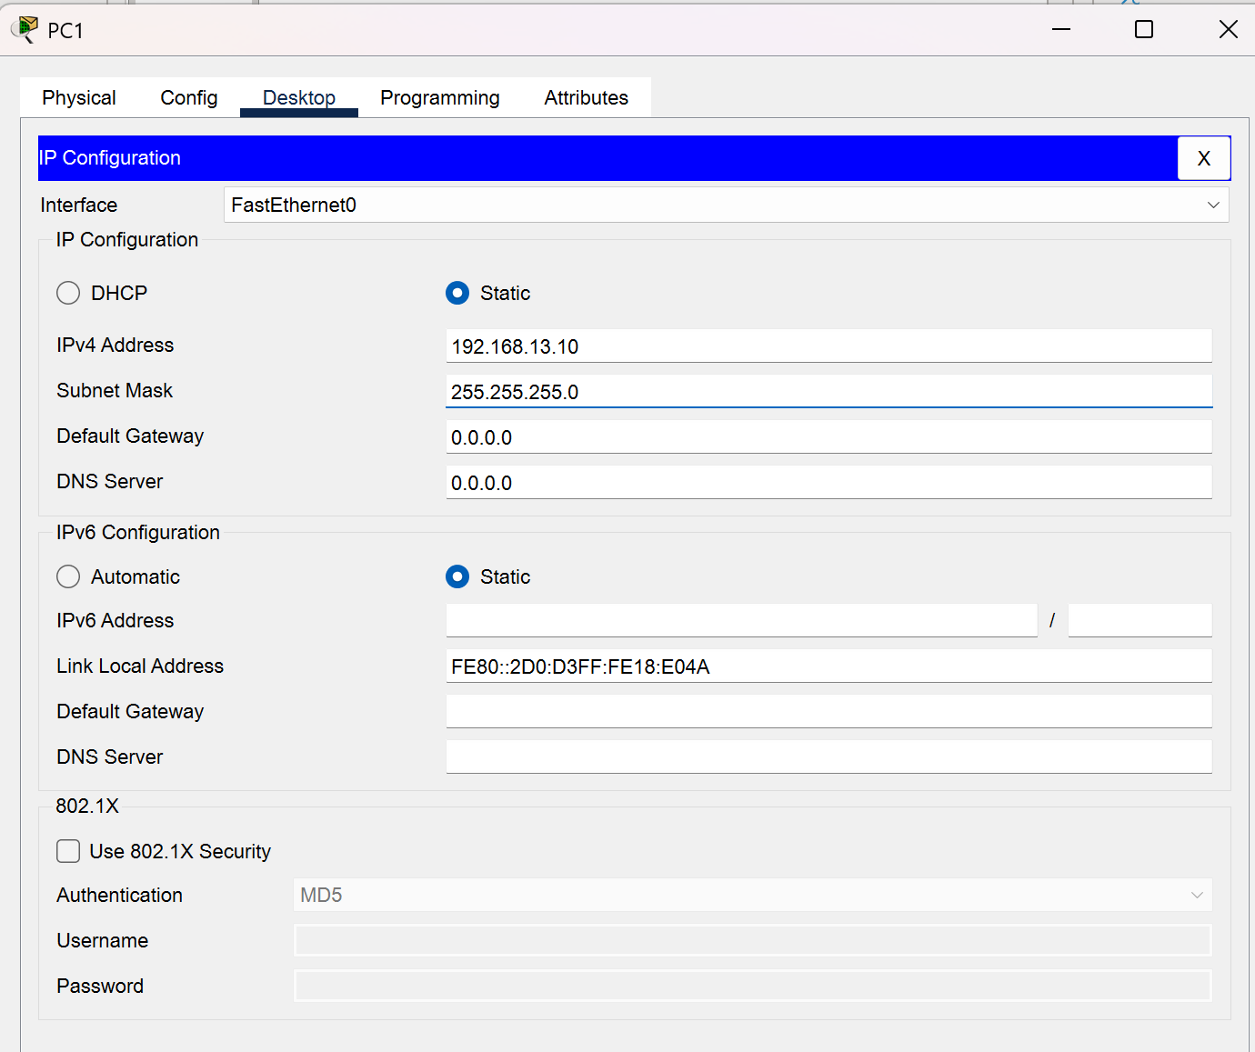
C:\>ipconfig

FastEthernet0 Connection:(default port)

Connection-specific DNS Suffix..:
Link-local IPv6 Address.........: FE80::2D0:D3FF:FE18:E04A
IPv6 Address....................: ::
IPv4 Address....................: 192.168.13.10
Subnet Mask.....................: 255.255.255.0
Default Gateway.................: ::
0.0.0.0

Bluetooth Connection:

Connection-specific DNS Suffix..:
Link-local IPv6 Address.........: ::
IPv6 Address....................: ::
IPv4 Address....................: 0.0.0.0
Subnet Mask.....................: 0.0.0.0
Default Gateway.................: ::
0.0.0.0

C:\>ping 192.168.13.13

Pinging 192.168.13.13 with 32 bytes of data:

Request timed out.
Reply from 192.168.13.13: bytes=32 time<1ms TTL=255
Reply from 192.168.13.13: bytes=32 time<1ms TTL=255
Reply from 192.168.13.13: bytes=32 time<1ms TTL=255

Ping statistics for 192.168.13.13:
Packets: Sent = 4, Received = 3, Lost = 1 (25% loss),
Approximate round trip times in milli-seconds:
Minimum = 0ms, Maximum = 0ms, Average = 0ms

C:\>telnet 192.168.13.13
Trying 192.168.13.13 ...Open

User Access Verification

Password: vty
Switch13>

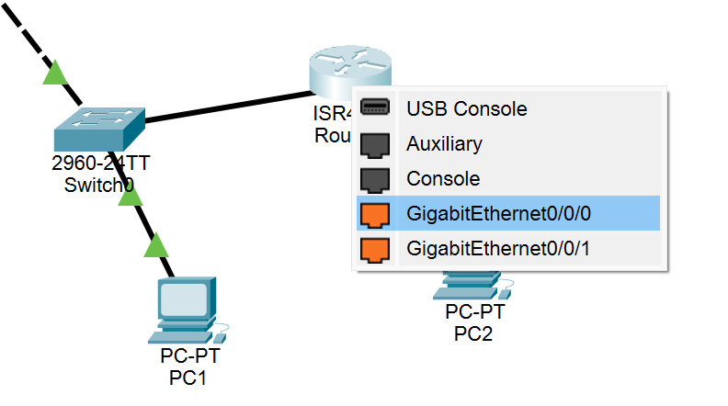

Настройка шлюза по умолчанию
НА роутере
--- System Configuration Dialog ---

Would you like to enter the initial configuration dialog? [yes/no]:
% Please answer 'yes' or 'no'.
Would you like to enter the initial configuration dialog? [yes/no]: yes

At any point you may enter a question mark '?' for help.
Use ctrl-c to abort configuration dialog at any prompt.
Default settings are in square brackets '[]'.

Basic management setup configures only enough connectivity
for management of the system, extended setup will ask you
to configure each interface on the system

Would you like to enter basic management setup? [yes/no]: y
Configuring global parameters:

Enter host name [Router]: Router13

The enable secret is a password used to protect access to
privileged EXEC and configuration modes. This password, after
entered, becomes encrypted in the configuration.
Enter enable secret: cisco

The enable password is used when you do not specify an
enable secret password, with some older software versions, and
some boot images.
Enter enable password: cisco
% Please choose a password that is different from the enable secret
Enter enable password: 1234

The virtual terminal password is used to protect
access to the router over a network interface.
Enter virtual terminal password: vty
Configure SNMP Network Management? [no]:

Current interface summary

Interface IP-Address OK? Method Status Protocol

GigabitEthernet0/0/0 unassigned YES manual administratively down down

GigabitEthernet0/0/1 unassigned YES manual administratively down down

GigabitEthernet0/0/2 unassigned YES manual administratively down down

Vlan1 unassigned YES manual administratively down down

Enter interface name used to connect to the
management network from the above interface summary: GigabitEthernet0/0/0

Configuring interface GigabitEthernet0/0/0:
Configure IP on this interface? [yes]: y
IP address for this interface: 192.168.13.1
Subnet mask for this interface [255.255.255.0] :

The following configuration command script was created:

!
hostname Router13
enable secret 5 $1$mERr$hx5rVt7rPNoS4wqbXKX7m0
enable password 1234
line vty 0 4
password vty
!
interface Vlan1
shutdown
no ip address
!
interface GigabitEthernet0/0/0
no shutdown
ip address 192.168.13.1 255.255.255.0
!
interface GigabitEthernet0/0/1
shutdown
no ip address
!
interface GigabitEthernet0/0/2
shutdown
no ip address
!
end

[0] Go to the IOS command prompt without saving this config.
[1] Return back to the setup without saving this config.
[2] Save this configuration to nvram and exit.

Enter your selection [2]:
Building configuration...
[OK]
Use the enabled mode 'configure' command to modify this configuration.

Press RETURN to get started!

%LINK-5-CHANGED: Interface Vlan1, changed state to up

%LINK-5-CHANGED: Interface GigabitEthernet0/0/0, changed state to up

%LINEPROTO-5-UPDOWN: Line protocol on Interface GigabitEthernet0/0/0, changed state to up

%LINK-5-CHANGED: Interface GigabitEthernet0/0/1, changed state to up

%LINEPROTO-5-UPDOWN: Line protocol on Interface GigabitEthernet0/0/1, changed state to up

%LINK-5-CHANGED: Interface GigabitEthernet0/0/2, changed state to up

%LINK-5-CHANGED: Interface Vlan1, changed state to administratively down

%LINK-5-CHANGED: Interface GigabitEthernet0/0/1, changed state to administratively down

%LINEPROTO-5-UPDOWN: Line protocol on Interface GigabitEthernet0/0/1, changed state to down

%LINK-5-CHANGED: Interface GigabitEthernet0/0/2, changed state to administratively down

%SYS-5-CONFIG_I: Configured from console by console

Router13>enable
Password: cisco
Router13#show interfaces gigabitethernet0/0/0
GigabitEthernet0/0/0 is up, line protocol is up (connected)
Hardware is ISR4331-3x1GE, address is 00e0.f79e.7701 (bia 00e0.f79e.7701)
Internet address is 192.168.13.1/24
MTU 1500 bytes, BW 1000000 Kbit, DLY 10 usec,
reliability 255/255, txload 1/255, rxload 1/255
Encapsulation ARPA, loopback not set
Keepalive not supported
Full Duplex, 1000Mbps, link type is auto, media type is Auto Select
output flow-control is on, input flow-control is on
ARP type: ARPA, ARP Timeout 04:00:00,
Last input 00:00:08, output 00:00:05, output hang never
Last clearing of "show interface" counters never
Input queue: 0/375/0 (size/max/drops); Total output drops: 0
Queueing strategy: fifo
Output queue :0/40 (size/max)
5 minute input rate 0 bits/sec, 0 packets/sec
5 minute output rate 0 bits/sec, 0 packets/sec
0 packets input, 0 bytes, 0 no buffer
Received 0 broadcasts (0 IP multicasts)
0 runts, 0 giants, 0 throttles
0 input errors, 0 CRC, 0 frame, 0 overrun, 0 ignored
0 watchdog, 1017 multicast, 0 pause input

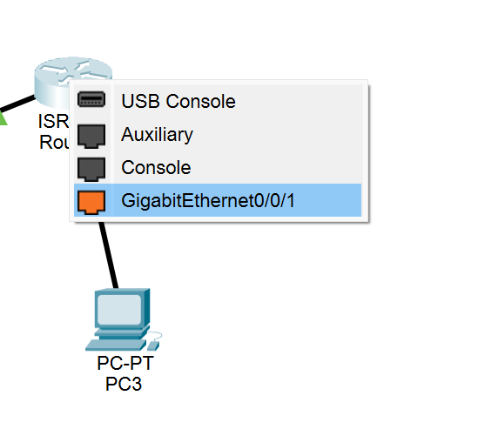
Router13#conf t
Enter configuration commands, one per line. End with CNTL/Z.
Router13(config)#interface gigabitethernet0/0/1
Router13(config-if)#no shutdown

Router13(config-if)#
%LINK-5-CHANGED: Interface GigabitEthernet0/0/1, changed state to up

%LINEPROTO-5-UPDOWN: Line protocol on Interface GigabitEthernet0/0/1, changed state to up

Теперь соединение зеленое

Router13#show ip interface brief
Interface IP-Address OK? Method Status Protocol
GigabitEthernet0/0/0 192.168.13.1 YES manual up up
GigabitEthernet0/0/1 unassigned YES unset up up
GigabitEthernet0/0/2 unassigned YES unset administratively down down
Vlan1 unassigned YES unset administratively down down
Router13#conf t
Enter configuration commands, one per line. End with CNTL/Z.
Router13(config)#interface gigabitethernet0/0/1
Router13(config-if)#ip address 192.168.14.1 255.255.255.0
Router13(config-if)#no shutdown
Router13(config)#ip routing
Router13(config)#do show ip interface brief
Interface IP-Address OK? Method Status Protocol
GigabitEthernet0/0/0 192.168.13.1 YES manual up up
GigabitEthernet0/0/1 192.168.14.1 YES manual up up
GigabitEthernet0/0/2 unassigned YES unset administratively down down
Vlan1 unassigned YES unset administratively down down

На PC3 выполните:
bash
C:\> ping 192.168.13.10

Ожидаемый результат:
❌ Узел НЕ ДОСТУПЕН (будет Request timed out)

Почему узел не доступен?
Причина:
- PC3 находится в сети 192.168.14.0/24
- PC1 находится в сети 192.168.13.0/24
- Коммутатор Switch13 не знает маршрут к сети 192.168.14.0/24
Решение:
Нужно настроить шлюз по умолчанию на PC1 и Switch13:
На PC1:
- Desktop → IP Configuration
- Default Gateway: 192.168.13.1
На Switch13:
bash
Switch13# configure terminal
Switch13(config)# ip default-gateway 192.168.13.1
Switch13(config)# exit
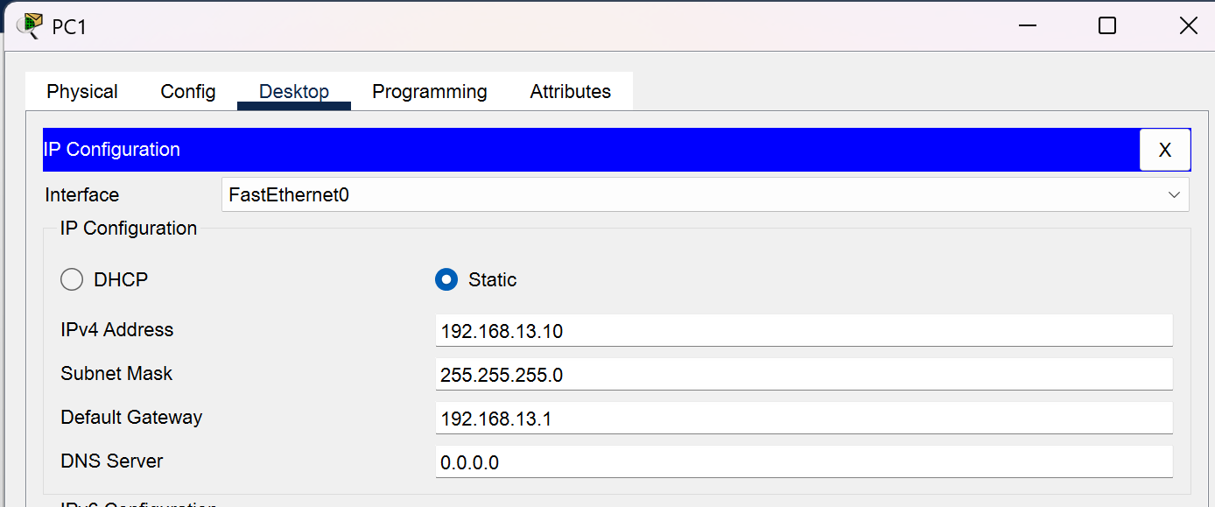

Switch13>enable
Password:
Switch13#conf t
Enter configuration commands, one per line. End with CNTL/Z.
Switch13(config)#ip default-gateway 192.168.13.1

Настройка IP-адреса на PC3:
Шаг 1: Настройте статический IP на PC3
- Закройте Command Prompt на PC3
- Перейдите: Desktop → IP Configuration
- Убедитесь, что выбран FastEthernet0 (в выпадающем списке вверху)
- Выберите "Static" и введите:
  - IP Address: 192.168.14.10
  - Subnet Mask: 255.255.255.0
  - Default Gateway: 192.168.14.1
C:\>ipconfig

FastEthernet0 Connection:(default port)

Connection-specific DNS Suffix..:
Link-local IPv6 Address.........: FE80::240:BFF:FECA:A691
IPv6 Address....................: ::
IPv4 Address....................: 192.168.14.10
Subnet Mask.....................: 255.255.255.0
Default Gateway.................: ::
192.168.14.1

Bluetooth Connection:

Connection-specific DNS Suffix..:
Link-local IPv6 Address.........: ::
IPv6 Address....................: ::
IPv4 Address....................: 0.0.0.0
Subnet Mask.....................: 0.0.0.0
Default Gateway.................: ::
0.0.0.0

Проверка связи с маршрутизатором

C:\>ping 192.168.14.1

Pinging 192.168.14.1 with 32 bytes of data:

Reply from 192.168.14.1: bytes=32 time=11ms TTL=255
Reply from 192.168.14.1: bytes=32 time<1ms TTL=255
Reply from 192.168.14.1: bytes=32 time<1ms TTL=255
Reply from 192.168.14.1: bytes=32 time=15ms TTL=255

Ping statistics for 192.168.14.1:
Packets: Sent = 4, Received = 4, Lost = 0 (0% loss),
Approximate round trip times in milli-seconds:
Minimum = 0ms, Maximum = 15ms, Average = 6ms

Первый пакет потерялся
PC3 не знает MAC-адрес PC1
Первый ping - это ARP-запрос для поиска MAC-адреса
Последующие пакеты идут нормально, так как ARP-таблица заполнена

C:\>ping 192.168.13.10

Pinging 192.168.13.10 with 32 bytes of data:

Request timed out.
Reply from 192.168.13.10: bytes=32 time<1ms TTL=127
Reply from 192.168.13.10: bytes=32 time<1ms TTL=127
Reply from 192.168.13.10: bytes=32 time<1ms TTL=127

Ping statistics for 192.168.13.10:
Packets: Sent = 4, Received = 3, Lost = 1 (25% loss),
Approximate round trip times in milli-seconds:
Minimum = 0ms, Maximum = 0ms, Average = 0ms

C:\>ping 192.168.13.10

Pinging 192.168.13.10 with 32 bytes of data:

Reply from 192.168.13.10: bytes=32 time<1ms TTL=127
Reply from 192.168.13.10: bytes=32 time<1ms TTL=127
Reply from 192.168.13.10: bytes=32 time<1ms TTL=127
Reply from 192.168.13.10: bytes=32 time=25ms TTL=127

Ping statistics for 192.168.13.10:
Packets: Sent = 4, Received = 4, Lost = 0 (0% loss),
Approximate round trip times in milli-seconds:
Minimum = 0ms, Maximum = 25ms, Average = 6ms

Сохранение конфигурации
Switch13#copy running-config startup-config
Destination filename [startup-config]?
Building configuration...
[OK]
Switch13#

Настройка баннера входа
Switch13#conf t
Enter configuration commands, one per line. End with CNTL/Z.
Switch13(config)#banner motd %
Enter TEXT message. End with the character '%'.
WARNING - WARNING - WARNING - WARNING - WARNING - WARNING -
WARNING%

Switch13#logout
Switch13 con0 is now available
Press RETURN to get started.
WARNING - WARNING - WARNING - WARNING - WARNING - WARNING -
WARNING

Switch13>enable
Password:
Switch13#

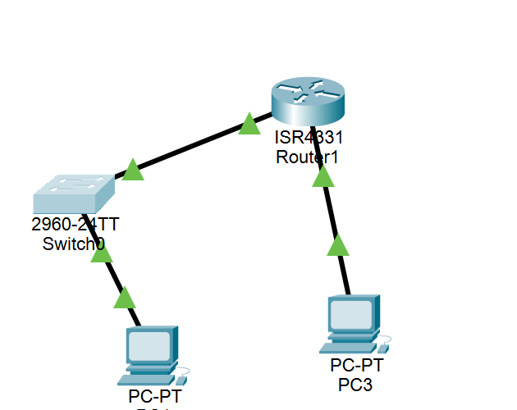

Первая проба
A summary of U.S. laws governing Cisco cryptographic products may be found at:
http://www.cisco.com/wwl/export/crypto/tool/stqrg.html
If you require further assistance please contact us by sending email to
export@cisco.com.
cisco WS-C2960-24TT-L (PowerPC405) processor (revision B0) with 65536K bytes of memory.
Processor board ID FOC1010X104
Last reset from power-on
1 Virtual Ethernet interface
24 FastEthernet interfaces
2 Gigabit Ethernet interfaces
The password-recovery mechanism is enabled.
64K bytes of flash-simulated non-volatile configuration memory.
Base ethernet MAC Address : 00:D0:97:C5:98:9B
Motherboard assembly number : 73-10390-03
Power supply part number : 341-0097-02
Motherboard serial number : FOC10093R12
Power supply serial number : AZS1007032H
Model revision number : B0
Motherboard revision number : B0
Model number : WS-C2960-24TT-L
System serial number : FOC1010X104
Top Assembly Part Number : 800-27221-02
Top Assembly Revision Number : A0
Version ID : V02
CLEI Code Number : COM3L00BRA
Hardware Board Revision Number : 0x01

Switch Ports Model SW Version SW Image
------ ----- ----- ---------- ----------
* 1 26 WS-C2960-24TT-L 15.0(2)SE4 C2960-LANBASEK9-M

Cisco IOS Software, C2960 Software (C2960-LANBASEK9-M), Version 15.0(2)SE4, RELEASE SOFTWARE (fc1)
Technical Support: http://www.cisco.com/techsupport
Copyright (c) 1986-2013 by Cisco Systems, Inc.
Compiled Wed 26-Jun-13 02:49 by mnguyen

Press RETURN to get started!

%LINK-5-CHANGED: Interface FastEthernet0/1, changed state to up

%LINEPROTO-5-UPDOWN: Line protocol on Interface FastEthernet0/1, changed state to up

Switch>enable
Switch#configure terminal
Enter configuration commands, one per line. End with CNTL/Z.
Switch(config)#

Switch con0 is now available

Press RETURN to get started.

Switch>enable
Switch#configure terminal
Enter configuration commands, one per line. End with CNTL/Z.
Switch(config)#hostname SwitchX
SwitchX(config)#enable password 1234
SwitchX(config)#show running-config
^
% Invalid input detected at '^' marker.
SwitchX(config)#show running-config
^
% Invalid input detected at '^' marker.
SwitchX(config)#show running-config
^
% Invalid input detected at '^' marker.
SwitchX(config)# show running-config
^
% Invalid input detected at '^' marker.
SwitchX(config)#
SwitchX(config)#
SwitchX#
%SYS-5-CONFIG_I: Configured from console by console

SwitchX#show running-config
Building configuration...

Current configuration : 1104 bytes
!
version 15.0
no service timestamps log datetime msec
no service timestamps debug datetime msec
no service password-encryption
!
hostname SwitchX
!
enable password 1234
!
!
!
!
!
!
spanning-tree mode pvst
spanning-tree extend system-id
!
interface FastEthernet0/1

SwitchX#enable
SwitchX#disable
SwitchX>
SwitchX>enable
Password:
SwitchX#enable secret 12345
^
% Invalid input detected at '^' marker.
SwitchX#configure terminal
Enter configuration commands, one per line. End with CNTL/Z.
SwitchX(config)#enable secret 12345
SwitchX(config)#
SwitchX#
%SYS-5-CONFIG_I: Configured from console by console

SwitchX#show running-config
Building configuration...

Current configuration : 1151 bytes
!
version 15.0
no service timestamps log datetime msec
no service timestamps debug datetime msec
no service password-encryption
!
hostname SwitchX
!
enable secret 5 $1$mERr$/Q/mbs3O9oHsKR7rNG4e81
enable password 1234
!
!
!
!
!
!
spanning-tree mode pvst
spanning-tree extend system-id
!
interface FastEthernet0/1
!

SwitchX#disable
SwitchX>enable secret 12345
^
% Invalid input detected at '^' marker.
SwitchX>enable
Password:
SwitchX#line vty 0 15
^
% Invalid input detected at '^' marker.
SwitchX#configure terminal
Enter configuration commands, one per line. End with CNTL/Z.
SwitchX(config)#line vty 0 15
SwitchX(config-line)#password 1234
SwitchX(config-line)#login
SwitchX(config-line)#running-condig
^
% Invalid input detected at '^' marker.
SwitchX(config-line)#
SwitchX#
%SYS-5-CONFIG_I: Configured from console by console

SwitchX#running config
^
% Invalid input detected at '^' marker.
SwitchX#running-config
Translating "running-config"...domain server (255.255.255.255)

